Name:
Date of Training:
Training Quiz

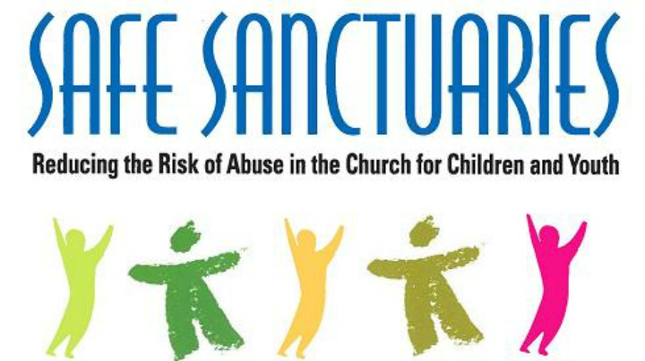

- A mandatory reporter is required by law to report a suspected child abuse.
Who is considered a mandatory reporter?
- People who interact with children on a regular basis
- Private Citizens
- Public professionals
- All the above

2.Physical abuse is defined as- any __________ of a child or any _________

____________ to a child which has been caused by any other than ________________.

- What are the four categories that are included in Sexual abuse?
- 2.
3. 4.

- Neglect of a child is defined as, but not limited to:
1.
2.
3.
4.

- Mental injury to a child includes only __________________ and substantial
________________ of the child’s mental and ______________________ ability to function caused by cruelty to a child.

- Threat of harm is when a parent or a care giver subjects a child to a substantial ____________ of ____________ to the child’s __________________ or ____________________.

- You do not have to be certain about abuse to make a report.
_____True ____False

- List the three step process that Edgar shares of making a mandatory report?
1.
2.
3.
- To Recognize an abuse is knowing the ____________________ that abuse has occurred or may be occurring.

- What are beliefs and personal biases we need to be aware of when considering making a Report of child abuse that can influence our thoughts and actions?

- __________________ __________________ children of color who are reported far more often than expected.
- Often ______________________ differences equate to ____________________ differences.
- Do you worry that different __________________ or __________________ groups are somehow a threat to your personal property or security?

- What are the three categories and warning signs of abuse:
1.
2.
3.
- What are the five specific situations that raise concern for mandatory reports in regards to a child’s safety and well-being ?
1.
2.
3.
4.
5.

- List important information you should Record prior to making a report?

- If you witnessed an abuse you are the responsible reporter and will need to call the New York State Child Abuse Hotline 1-800-342-3720 Once you provide your contact information, you have net your responsibility as a mandatory reporter.

