The Walk Sheet- Rooted #1 Planted Firmly
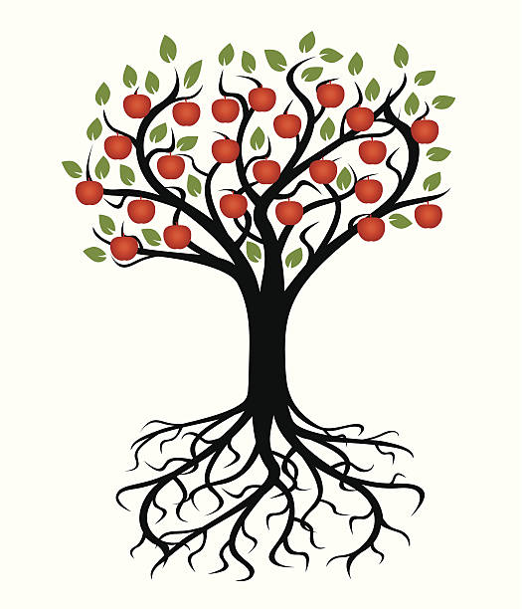
AM TWIGS Class – March 7th
Psalms 1:3 2 Corinthians 9:10

- Why do famers plant Apple Trees near each other? How is your spiritual life impacted by staying connected or close to other believers?

- Why does the seed of salvation planted in your heart mark the beginning of your growth and walk with Jesus?

- God uses people to sow seeds of faith in others, Who has sown seeds of faith in you?

- Think of someone in your life that does not know Jesus, how can you sow seeds of God’s love and salvation with them?

- What are some things you can do to continue growing and staying strong in your faith? Take time to pray about it and then make it a habit to plant those seeds into your day.

