40 Bible Trivia Questions for Kids
Help your younger students study and play all at once with a Bible quiz for kids! Fun Bible trivia is the best way to let kids test their knowledge of the Bible without it feeling like a chore. If you successfully make it a fun activity, they won’t even feel like it's studying!
Looking for a way to spruce up the energy at your kids’ ministry? Look no further. We have gathered 100 of the best Bible questions and answers for kids to blend Bible study with fun and excitement. Bring a splash of energy into your ministry this Sunday with child Bible trivia!
These trivia questions are an ideal way to add excitement to your children’s ministry while learning important facts about the Bible too! Set it up as a fun activity and let your students share their Biblical knowledge, so you know just how well you have taught them. If you have been covering something specific in class with your curriculum, why not incorporate a few other questions that are relevant to what you have been working on? Use kids' Bible trivia questions to transform Bible study into a game and play it as often as you want. Whether you include ten easy Bible questions for kids every Sunday or have one mega-quiz to test their knowledge, you can incorporate these into your classes effortlessly. Have fun with children’s Bible trivia!

Here are 40 easy Bible trivia questions for kids:
‍

1. How many commandments are there?
There are ten commandments
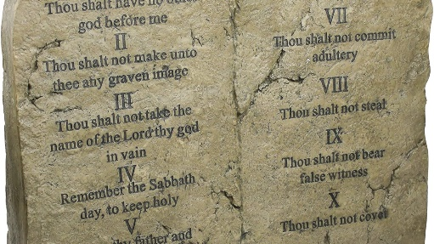

2. Name three of the ten commandments.
Child can choose any three from:
- I am the Lord your God. You shall not have strange gods before me.
- You shall not take the name of the Lord your God in vain.
- Remember to keep holy the Sabbath day.
- Honor your father and your mother.
- You shall not kill.
- You shall not commit adultery.
- You shall not steal.
- You shall not bear false witness against your neighbor.
- You shall not covet your neighbor’s wife.
- You shall not covet your neighbor’s goods.

3. What’s the first book in the Bible?
Genesis is the first book in the Bible

4. How many of each animal came onto the ark? Why?
Two of each animal came onto the ark so the species could continue

5. Who built the ark?
Noah built the ark

6. When did Jesus rise from the dead?
Jesus rose from the dead on Easter Sunday

7. Who were the first people God created?
Adam and Eve were the first humans created by God

8. Who betrayed Jesus?
Judas betrayed Jesus

9. For how many days and nights did Jesus fast?
Jesus fasted for forty days and forty nights
‍

10. Why did Adam and Eve get expelled from the Garden of Eden?
They were expelled because Eve took a bite of the forbidden fruit
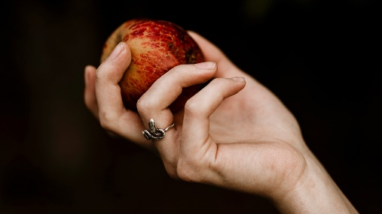

11. For how many days was Jesus in the tomb?
Jesus was in the tomb for three days

12. What happened on Palm Sunday?
On Palm Sunday Jesus entered Jerusalem on a donkey, just before his death

13. Who baptized Jesus?
John the Baptist baptized Jesus

14. What is the common name of the first four books in the New Testament?
The first four books are commonly known as The Gospels

15. Where was Jesus crucified?
Jesus was crucified in Jerusalem

16. How many apostles did Jesus have?
Jesus had 12 apostles

17. Which is the most sold book in the world?
The Bible is the most sold book

18. Where did Jesus grow up?
Jesus grew up in Nazareth

19. Who were the ten commandments given to?
Moses received the ten commandments
‍

20. Who was given the coat of many colors?
Joseph was given the coat with many colors
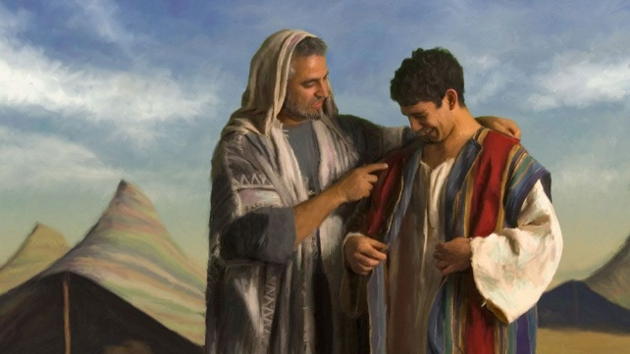
‍

21. What sea did Jesus calm in the storm?
He calmed the Sea of Galilee

22. How many times did Peter deny Jesus?
Peter denied Jesus three times

23. What language was the Bible originally written in?
The Bible was originally written in Hebrew

24. What did Joseph do for work?
Joseph was a carpenter

25. Why did God send the ten plagues?
He sent them because the Pharaoh would not set the Israelites free

26. What did God use to create Eve?
He used the rib of Adam to create Eve

27. Who were the first children on this Earth?
Cain and Abel were the first children born on this Earth

28. Who did God appear to as a burning bush on the mountain of God?
God appeared to Moses as a burning bush

29. How many books are in the Bible?
There are a total of 66 books in the Bible
‍

30. What does the word Gospel mean?
Gospel means ‘good news’
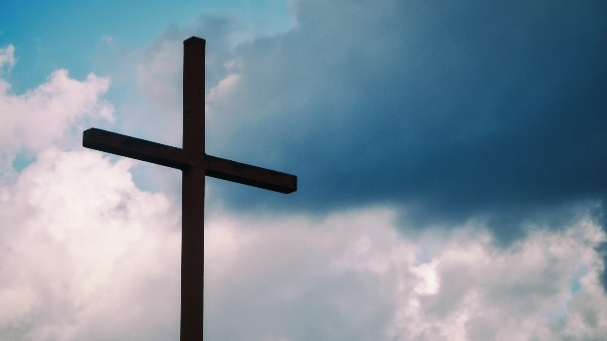

‍

31. What did God create on the second day?
On the second day, God created the sky

32. How did Jesus die?
Jesus was crucified – he died on the cross.

33. Who was the King of Judea when Jesus was born?
Herold the Great

34. After Jesus was arrested, which apostle disowned him?
Peter disowned Jesus after he was arrested

35. What did Jesus turn into wine?
Jesus turned water into wine

36. With what food did Jesus feed the 5000?
He fed the 5000 with bread and fish

37. Who was killed by their brother?
Abel killed his brother Cain

38. Who fought the giant, Goliath?
David fought Goliath

39. Where was Moses born?
Moses was born in Egypt
‍

40. Who wrote the book of revelation?
John was the author of the book of revelation
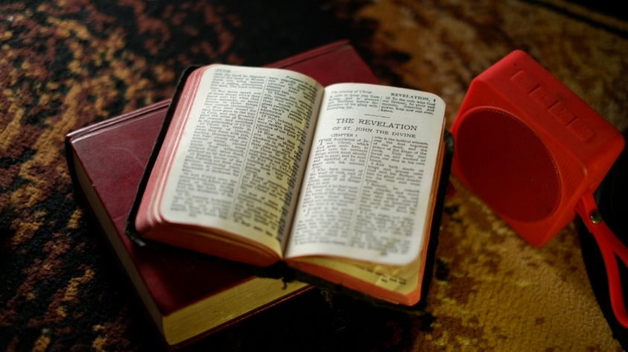

‍

Bonus Question: How many fish did Jesus have to feed the 5000?
Jesus only had two fish to feed the 5000

