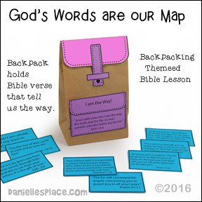
Backpack Craft
What you will need:
Different Colors of Paper
Paper Lunch Bags
School Glue
Scissors
Tape

Say: When God asked Abraham and Sarah to leave their home, they may have been worried or scared. But God promised that he would guide them and be with them, His words in the Bible are our map. Today we are going to make this backpack and fill it with Bible verses that remind us that God will always guide and be with us.

How to make a paper backpack:
1. Print out the backpack patterns and Bible verse cards onto colorful paper and cut them out.
2. Cut the top of regular-sized lunch bags so it is 8″ high or to match the size of the pattern. Glue the back pattern to the back of the lunch bag and fold over the flap to the front. Glue the rest of the patterns to the bag as shown in the picture.
3. Have your children place the Bible verse cards inside their backpacks. Instead of printing out the Bible verses, you can have your students write their favorite Bible verse on index cards. Give them a list of Bible verse to pick from.

